Create Client

Create Client : អ្នកដែលត្រូវការ Token from Auth server to verify with Resource server
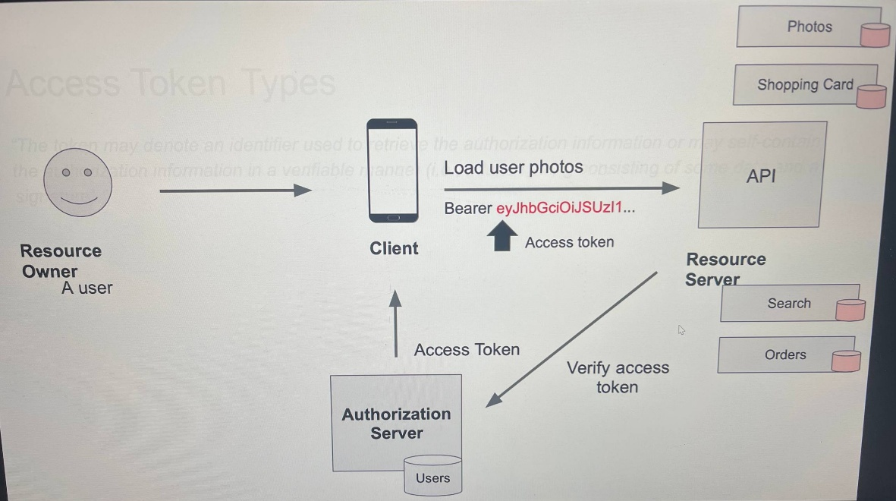

- General Setting

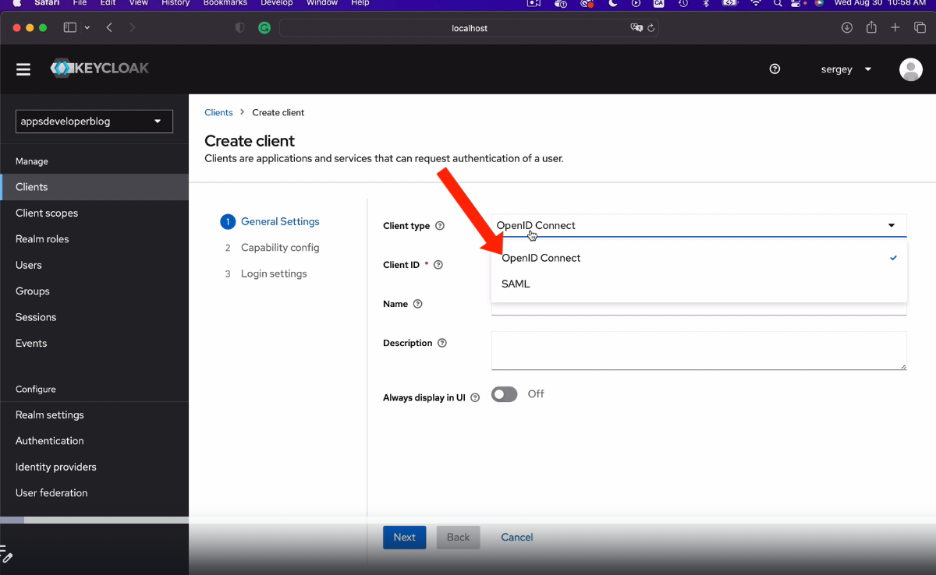

- openID Connection : extend from OAuth2: It contains user's identity data in a Json format, and this protocol is mainly used for web and mobile.

- Saml is an older protocol that is independent of oath. It uses XML as data format. It is more feature rich and it is mainly used for enterprise and government applications that need to authenticate users and access more complex identity data.

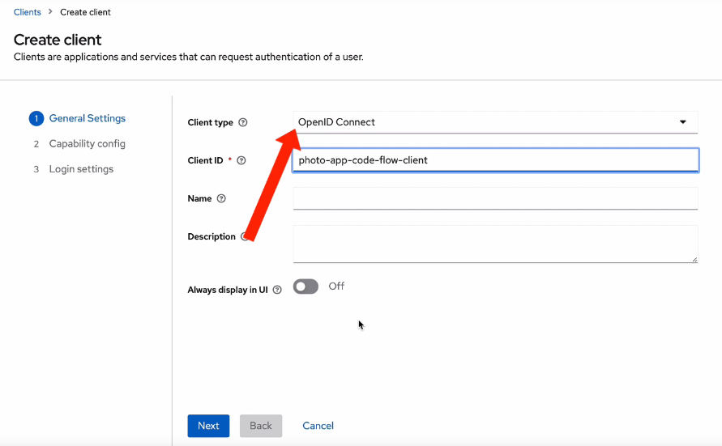

- Client ID: The client identifier registered with the identity provider. ឈ្មោះសំគាល់ client របស់យើង
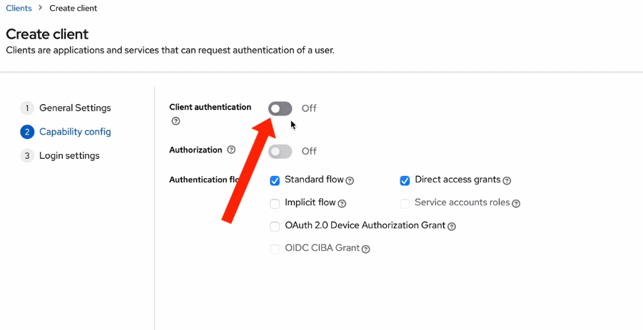

- ពេលយើងអត់យក Client authentication មានន័យថា client របស់យើងវាជា Client publish. An example of application that does not use client secret value because it cannot store it securely is a JavaScript application that runs in a browser window because it runs in a browser window. សម្រាប់កម្មវិធី Javascript ដែលគេអាចធ្វើការមើលវាឃើញចឹង យើងមិនអាចដាក់វាបង្ហាញចឹងកើតនោះទេ
- Anybody can view its source code and this means that anybody can view its client secret value as well.
- So because these types of applications cannot store secret value securely, they usually use public
- OpenID client and you will most likely need to use authorization grant type for better security.

ចឹងយើងត្រូវបើកវា ដើម្បីអោយ client ដែលអាចធ្វើការរក្សាទុក Token បានដូចជា Server , native mobile app.
- Capability Setting

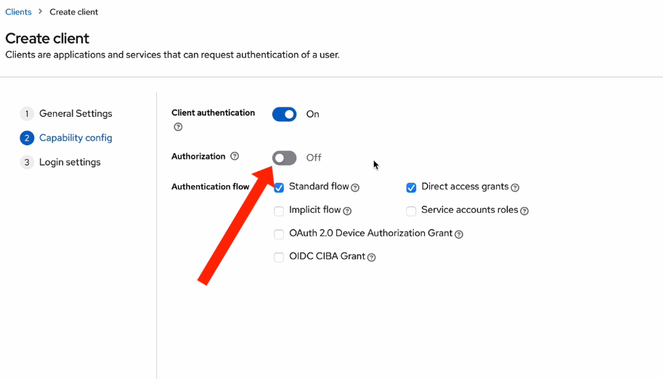

- យើងបើកវាដើម្បីអោយ Authoriztion can use with scopes and permissions.
- បើយើងយក The direct access grant is also selected, which means that a client has access to username and password​ យើងអោយ client can login with username and password
- Login Setting :

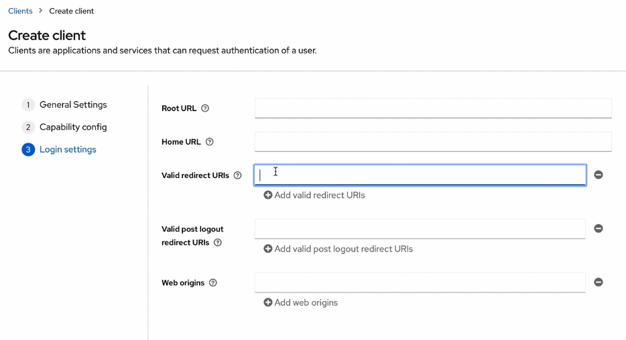

- Root url : យើងដាក់ url ដើមរបស់យើង បើមាន route ផ្សេងវានឹងបន្តពី URL នឹង​
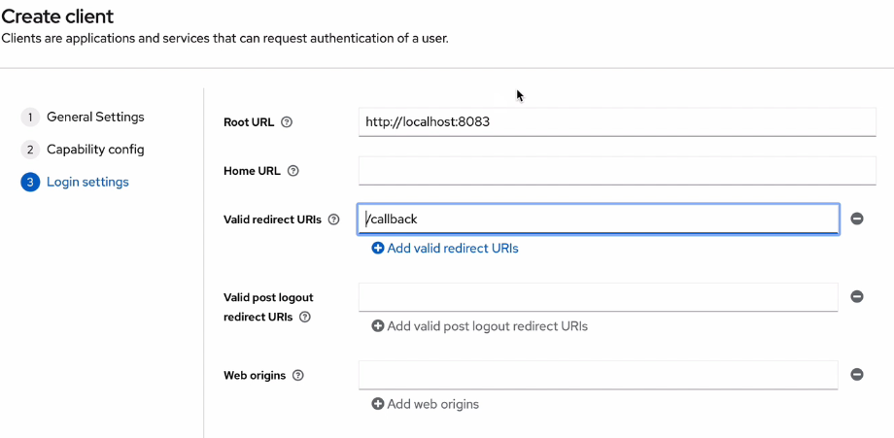

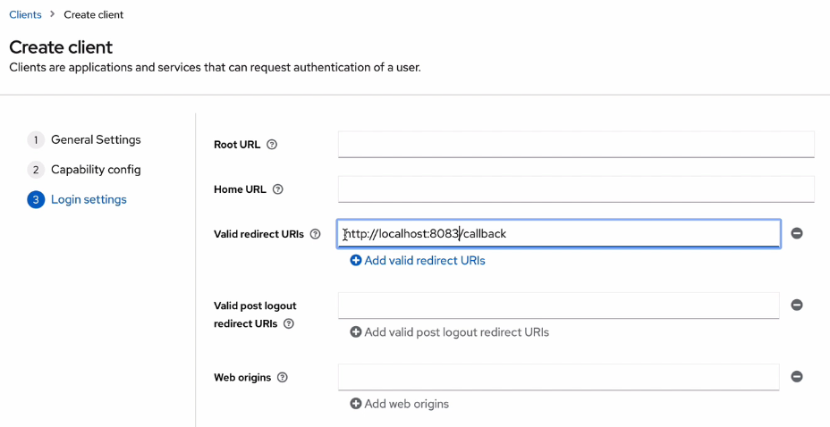
- សំខាន់ជាងគេគឺ Valid redirect URLs ពេលដែលវា success ហើយយើងអោយវាទៅណា

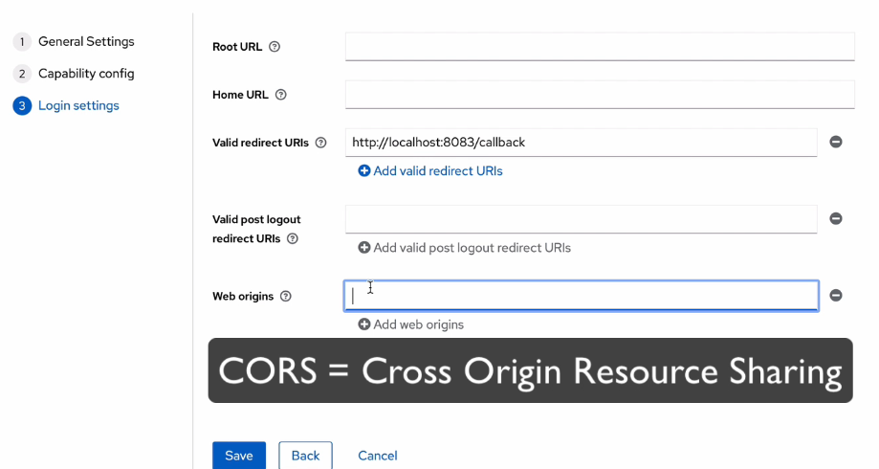

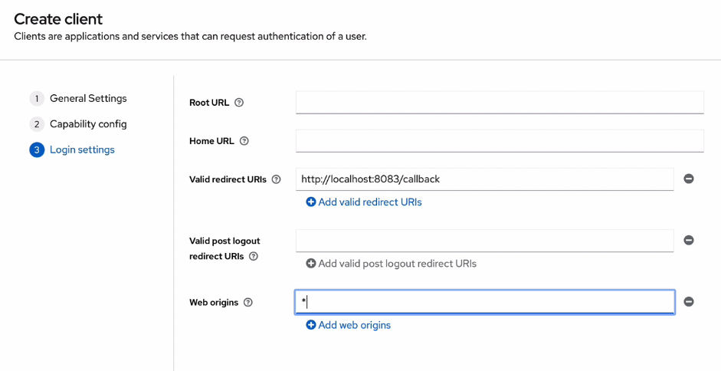

យើងដាក់សញ្ញា * មានន័យថា គ្រប់ Domain អាចធ្វើការ access មកបាន បើយើងចង់ filter យើងដាក់ + វិញ

បើយើងមិនចង់ Confir CORS ទេមិនបាច់ដាក់អីទេ

យើងត្រូវការ client ID and Client secreat ដើម្បីធ្វើការ Request token from Keyloak ដែលជា Auth server របស់យើង​
